
Honoring remarkable achievements of individuals and groups
who have made an impact on Clark County and beyond.
Service Recognition Award Nomination
Nominations due by October 24, 2025

Date: ____________________
Award Categories:
□ First Responder □ Military
□ Education □ Nonprofit
□ Good Samaritan □ Youth
□ Medical Field □ Business & Civic

Your Nomination: Your Information:
Name: ________________________________________ Name: _______________________________________
Employer: _____________________________________ Employer: ____________________________________
Address: _______________________________________ Address: ______________________________________
________________________________________ _______________________________________
Phone: ________________________________________ Phone: _______________________________________
Work Phone: __________________________________ Work Phone: ________________________________
Email: ________________________________________ Email: _______________________________________
You are asked to answer three questions and write a short nomination statement (under 500 words) that includes the actions and situations for which the individual is being nominated. Include any reports, news articles, pictures, names of witnesses and/or other awards received. Feel free to attach additional pages.

- Give us some background information that explains why you are nominating the individual or team.

- How has the nominee positively impacted their community?

- How has the nominee gone above and beyond their job duties and what were the results or impact?

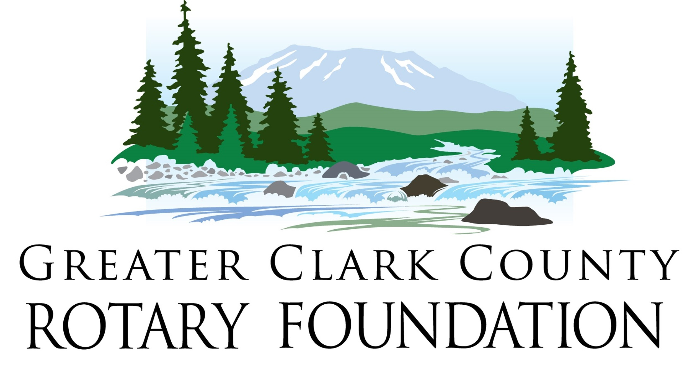
Submit nomination form to:
Email: nominations@rotarygcc.org



Honoring remarkable achievements of individuals and groups
who have made an impact on Clark County and beyond.
Award Guidelines & Requirements:
- Eligibility: All nominees must work or reside in Clark County, though their noteworthy acts may have occurred elsewhere.
- Commitment to Community: Nominees must demonstrate an ongoing commitment to the community for more than one year or have made a significant contribution in this year.
- Multiple Awards: It is possible for multiple people to be recognized in a single category for the same act of distinction.
- Selection Process: Our Selection Committee will choose those recognized based on service, merit, their adherence to our fundamental principles, and their availability for filming, and award acceptance.
- Category Flexibility: Nominees may meet the criteria for more than one category, and the Selection Committee may reassign them to a different category during deliberation.
Award Categories
- First Responder: Honors professionals or volunteers serving as law enforcement officials, firefighters, or first responders. This award celebrates acts of courage and selflessness in responding to emergencies, whether on or off duty, and their commitment to community service.
- Education: Acknowledges individuals who have actively contributed to enriching the Southwest Washington educational community through their service. Their efforts may have helped close the achievement gap or driven improvements in teaching and learning.
- Good Samaritan: The Good Samaritan recognition award is a heartfelt tribute to individuals or groups who embody the spirit of compassion, selflessness, and altruism through their service. This category aims to recognize those exceptional souls who have consistently gone above and beyond to lend a helping hand to those in need.
- Medical Field : Pays tribute to healthcare professionals, including doctors, nurses, and hospital staff, who have made exceptional contributions to the well-being of the community through their service.
- Military: Presented to members of the armed forces, whether active or veteran, commissioned or non-commissioned, whose actions have demonstrated exceptional courage or improved the welfare of the community through their service. This service recognition award may be given posthumously and extended to ROTC members or civilians/organizations significantly impacting the military community.
- Non-Profit: Celebrates businesses or individuals who have made significant contributions to non-profit organizations in our community. This award recognizes those who have shown dedication, compassion, and a strong commitment to making the world a better place through their actions and talents through their service.
- Youth: The Youth Recognition Award honors teenagers between the ages of 13 and 19 who demonstrate leadership through dedication to and achievement in community service, arts, academics, agriculture, athletics, music or a similar field.
- Business & Civic: Recognizes businesses or organizations that have made substantial contributions to the community and fostered positive impacts through their service.

Submit nomination form to:
Email: nominations@rotarygcc.org

